**EXERCISE-2**

1. Alter the table STUDENT with following structure.

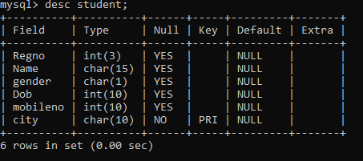

2. Alter the table name FACULTY with following structure. The DeptNo in this table refers the DeptNo in the DEPARTMENT table.

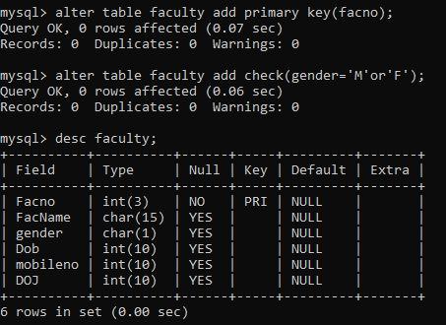

3. After the FACULTY table is successfully created, test if you can add a constraint FOREIGN KEY to the DeptNo of this table.

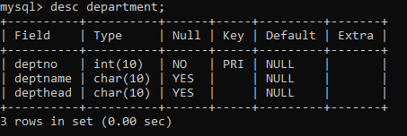

4. Alter the table name DEPARTMENT with following structure.



5. Alter the table name COURSE with following structure.

